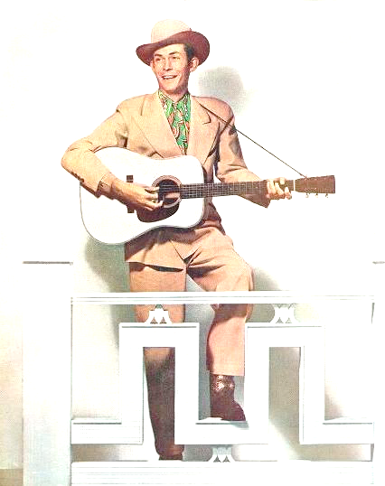
The Mixed Nuts

Set L Last revised on 2016.08.28

L01-Blue Room(K).2016.06.19.pdf
L02-Hello, Young Lovers(KVF).2015.01.18.pdf
L02-Hello, Young Lovers(KVM).2015.01.18.pdf
L03-Too Marvelous For Words(KVF).pdf
L03-Too Marvelous For Words(KVM).pdf
L04-I'm Gonna Sit Right Down And Write Myself A Letter(KVF).2015.01.18.pdf
L04-I'm Gonna Sit Right Down And Write Myself A Letter(KVM).2015.01.18.pdf
L05-Blueberry Hill(KVF).2015.01.18.pdf
L05-Blueberry Hill(KVM).2015.01.18.pdf
L06-Barbara Polka(K).2016.04.17.pdf
L07-Wind Beneath My Wings(KVF).2014.05.01.pdf
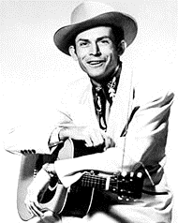
L07-Wind Beneath My Wings(KVM).2014.05.01.pdf
L08-Oh, You Beautiful Doll(KV).2016.04.17.pdf
L09-Cold, Cold Heart(KV).2016.04.17.pdf
L10-Jambalaya(KVF).2015.03.15.pdf
L10-Jambalaya(KVM).2015.03.15.pdf
L11-Your Cheatin' Heart(KVD).2016.05.29.pdf
L11-Your Cheatin' Heart(KVM).2016.04.26.pdf
L12-Yesterday When I Was Young(KV).2014.06.23.pdf
L13-King Of The Road(KV).2016.08.28.pdf
L14-When I Fall In Love(KVF).2014.09.15.pdf
L14-When I Fall In Love(KVM).2014.09.15.pdf
L15-New York, New York(KVF).2014.06.23.pdf
L15-New York, New York(KVM).pdf
L16-Love Is A Many-Spendored Thing(KVF).2016.06.19.pdf
L16-Love Is A Many-Spendored Thing(KVM).2016.06.19.pdf
L17-Stompin' At The Savoy(K).2015.01.18.pdf

